**First program :-**

1. #include <iostream>
2. using namespace std;
3. int main()
4. {
5. cout<<" Hello World!";
7. cout<<" I am learning c++";
8. return 0;
9. }

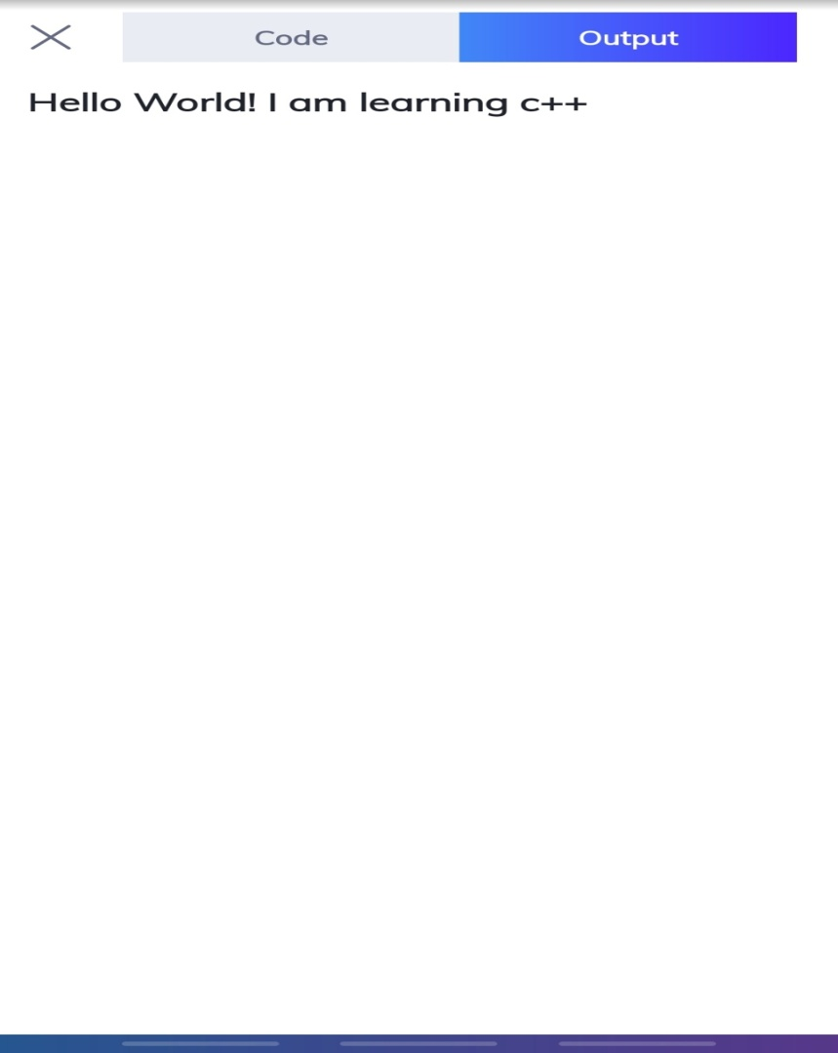**Output is below**

**Second program :- Linear Search program**

1. #include <iostream>
2. #define N 8
3. int main() {
4. int arr[N], flag=0, i, item;
5. for( i=0; i<N;i++)
6. std::cin>>arr[i];
7. std::cout<<"enter item for search";
8. std::cin>>item;
9. for(i=0;i<N;i++)
10. { flag=1;
11. break;
12. }
13. if (flag==1)
14. std::cout<<"item found";
15. else
16. std::cout<<"item not found";
17. }

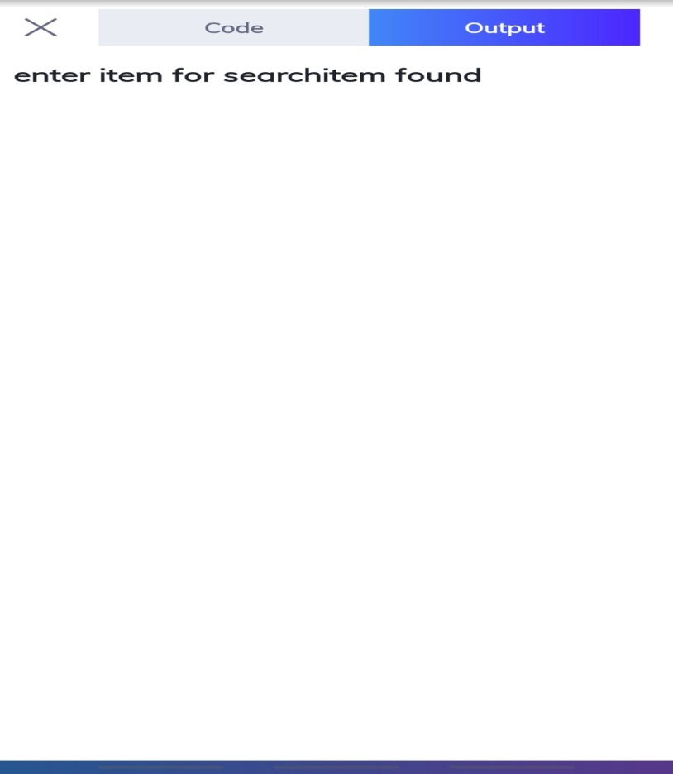**Output is below**